### **Install Opencv 4:**

1. **Download the Opencv** binary files here: <https://www.lfd.uci.edu/~gohlke/pythonlibs/#opencv>
2. **Choose** the compatible **version of Opencv** to your Python. We’ll download the lastest version of Opencv (4.1) for Python 3.6.8.  
   *How to understand the right version?  
   -cp37m-win32.whl means that Opencv is for python 3.7 (32 bit version)  
   -cp36m-win_amd64.whl means that Opencv is for python 3.6 (64 bit version)  
   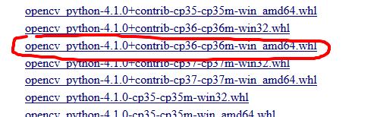*
3. **Run the “Command Prompt”** of Windows. You can type “CMD” on the sarch bar to find it.  
   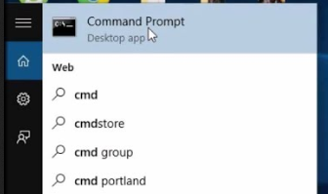
4. **Go to the directory where the Opencv binaries** that you downloaded is located.  
   cd YOURPATHfor example in my case:  
   cd C:\Users\pinolo\Downloads
5. Now let’s **install the Opencv module using PIP**.  
   python pip -m install opencv_python‑4.0.1+contrib‑cp37‑cp36m‑win_amd64.whl
6. Now let’s **install Numpy using PIP**.  
   python pip -m install numpy
7. **The installation is complete**. Now we can test it by running python and importing the libraries cv2 (for opencv) and numpy. If we don’t get any error it means that it has been installed succesfully.  
   